"Beatles forever!"

Сабитова Г.Р.
Газимова Э.Ф.
Цель урока: изучение лексики и грамматики английского языка на основе песни «When I’m Sixty-Four».
Задачи:
- знакомство с творчеством группы The Beatles;
- аудирование текста песни;
- повторение и изучение новых лексических и грамматических единиц.
На доске: фотографии членов группы и надпись: «John Lennon, Paul McCartney, George Harrison, Ringo Starr»; постеры группы; пластиноки и диски.

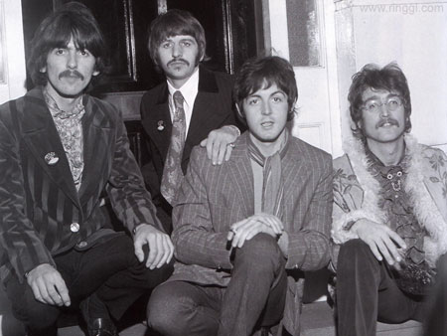
ХОД УРОКА
I. Знакомство с биографией членов группы и с творчеством The Beatles
Teacher: Today we’ll speak about the most famous British group “The Beatles”. Tell us what you know about this group.
Pupil 1: It is a very famous British rock group. It was formed by John Lennon, Paul McCartney, George Harrison and Ringo Starr. They became very popular in 1960s.
Pupil 2: They came from Liverpool, a town in the north of England. The Beatles had their first hit record in 1962. They gave concerts in Germany and America where they had a great success. Soon a hysteria which newspapers called “Beatlemania” swept Britain and soon America.
Pupil 3: After 1965 the Beatles worked mostly on films and albums. In the sixties they created successful records and interesting films. Their first movie was called “Hard day’s night”.
Pupil 4: The Beatles changed pop and rock music forever. From their first single, “Love Me Do” in 1962, people heard something different to the usual pop music of the time. Their songs seemed to be more musical than others. The Beatles also looked nicer than anyone else. Many more people began to listen to pop music than before.
Teacher: I’d like to ask you some questions:
- Are you fond of the Beatles?
- What their famous songs do you know?
- What is your favourite song?
- Why do you like this group?
- Do you have any Beatles records or CDs at home?
- Which one do you like most of all?
- Can you play the guitar?
- What are your other favourite groups?
II. Задача следующего этапа урока – аудирование (восприятие на слух) текста песни “When I’m Sixty-Four”.
Учитель раздает отпечатанный текст песни с пропущенными словами и фразами. Чтобы облегчить задачу учащимся, на доске можно выписать новые слова:
to feed – кормить, to scrimp – экономить,
to mend – чинить, to drop a line – написать,
a fuse – пробка, to indicate – указать,
a weed – сорняк, precisely – точно,
to dig – копать, to rent – арендовать.
Учащиеся по очереди диктуют слова, которые нужно вставить в текст:
When I get older (losing) my hair (many years) from now,
Will you still be sending me a (valentine),
Birthday greetings, (bottle) of wine?
If I’d been out till quarter to (three),
Would you (lock the door)?
Will you still (need me), will you still (feed me),
When I’m sixty-four?
(You’ll be) older too,
Ah, and if you say the word I (could stay) with you.
I could be (handy) mending a fuse
When your (lights) have gone.
You can knit a (sweater) by the fire side,
Sunday morning (go for a ride).
Doing the garden, (digging) the weeds,
Who could ask for more?
Will you still (need me), will you still (feed me),
When I’m sixty-four?
Every summer we can rent (a cottage)
In the Isle of Wight, if it’s not too (dear)
We shall scrimp and (save)
Grandchildren on your (knee); Vera, Chuck and Dave.
Send me a (postcard), drop me a line,
Stating point of view.
Indicate precisely what you mean to say,
Yours (sincerely), wasting away.
Give me your (answer), fill in a form, (mine) for evermore.
Will you still (need me), will you still (feed me),
When I’m sixty-four?
Пропущенные слова можно выписать на доске для проверки: loosing, many years, valentine, bottle, three, lock the door, need me, feed me, You’ll be, could stay, handy, lights, sweater, go for a ride, digging, a cottage, dear, save, knee, postcard, sincerely, answer, mine.
Выборочно можно перевести на русский язык некоторые фразы и предложения.
III. Повторив за учителем текст песни, учащиеся переходят к повторению некоторых грамматических явлений:
Teacher: Let’s review some grammar. Read the sentences, translate them and then give your own examples.
When I’m 64 (придаточное предложение времени)
When I get older, losing my hair (Participle I)
Would you lock the door? (Subjunctive Mood)
Will you still be sending me a valentine (Future Progressive)
When your lights have gone (Present Perfect)
Doing the garden, digging the weeds (Participle I)
Teacher: Let’s review the use of the articles: a valentine, a sweater, a fuse, a ride, a cottage; the word, the garden, the Isle of Wight, etc.
IV. Подведение итогов урока
Учащиеся исполняют хором песню.
Домашнее задание: сделать литературный перевод песни на русский язык.
Текс песни взят из сборника «Все песни BEATLES», издательский центр «Терра», 1997 г.

